Matlab Assignment

1. Suppose that x=2 and y=5. Use MATLAB to compute the following. (a)Yx^3/(x-y) (b) 3x/2y (c) 3xy/2 (d) x^5/(x^5-1)

**Solution:**

>> x=2;

>> y=5;

>> ans=(y*x^3)/(x-y) ans =

-13.3333

>> ans=(3*x)/(2*y) ans =

0.6

>> y=3/2*x*y y =

15

>> ans=(3*x)/(2*y) ans =

0.6

>> y=5;

>> ans=3*x/2*y ans =

15

>> ans=x^5/(x^5-1) ans =

1.0323

1. Assuming that the variable a, b, c, d and f are scalars. Write MATLAB statement to compute and display the following expression. Test your statements for the values a=1.12, b = 2.34, c = 0.72, d= 0.81 and f = 19.83.

(a)X= 1+a/b+c/f^2 (b) s=(b-a)/(d-c) (c) r = 1/(1/a+1/b+1/c+1/d)

(d) y=abf^2/2c

**Solution:**

>> a=1.12;b=2.34;c=0.72;d=0.81;f=19.83;

>> x=1+(a/b)+(c/f^2) x =

1.4805

>> s=(b-a)/(d-c) s =

13.5556

>> r=1/((1/a)+(1/b)+(1/c)+(1/d)) r =

0.2536

>> y=a*b*(1/c)*(f^2/2) y =

715.6766

1. Suppose that x= -7-5i and y = 4+3i. Use MATLAB to compute:

(a) x+y (b) xy (c) x/y

**Solution:**

>> x=-7-5*i;

>> y=4+3*i;

>> ans=x+y ans =

-3.0000 - 2.0000i

>> ans=x*y ans =

-13.0000 -41.0000i

>> ans=x/y ans =

-1.7200 + 0.0400i

1. The ideal gas law provides one way to estimate the pressure exerted by a gas in a container. The law is

P = nRT/V

More accurate estimates can be made with the van der Waals equation P

= nRT/(V-nb) - (an^2/V^2)

Where the term nb is correction for the volume of the molecules and the term an^2/V^2 is a correction of molecular attraction. The values of a and b depend on the type of gas. The gas constant is R, the absolute temperature si T, gas volume is V and the number of gas molecules is indicated by n. If n=1 mol where gas confined to a volume of V = 22.41 L at 0 degree C (273.2 K), it would exert a pressure of 1 atm. In this units, R = 0.08206.

For chlorine (CL2), a = 6.49 and b = 0.0562. Compare the pressure estimates given by the ideal gas law and the van der Waals equation for the 1 mole of CL2 in 22.41 L at 273.2K. What is the main cause of the difference in the two pressure estimates, the molecular volume or molecular attraction?

**Solution:**

>> n=1;v=22.41;R=0.08206;a=6.49;b=0.0562;T=273.2;

>> P=(n*R*T)/v P =

1.0004

>> P=((n*R*T)/(v-(n*b)))-(a*(n^2)/(v^2)) P =

0.9900

**Reason :** Main cause of the difference in 2 pressure estimates is molecular attraction.

5. Find the roots of 13x3+182x2-184x+2503=0

**Solution:**

>> P=[13 182 -184 2503] P =

13 182 -184 2503

>> roots(P) ans =

-15.6850 + 0.0000i

0.8425 + 3.4008i

0.8425 - 3.4008i

6 The Fourier series is a series representation of periodic function in terms of sines and cosines. The Fourier series representation of the function

F(x) = {1 0 < x < pi

{-1 pi < x < 0

Is

4/pi (sin x/1 + sin 3x/3 + sin 5x/5 + sin 7x/7 + ………)

Plot on the same graph the function f(x) and its series representation using the four terms shown in above equation.

**Solution:**

>> clear

>> t=0:0.1:pi;

>> y1=(4/pi)*(sin(t)+(sin(3*t)/3)+(sin(5*t)/5)+(sin(7*t)/7));

>> plot(t,y1);

>> hold on

>> t=-pi:0.1:0;

>> y2=(4/pi)*(sin(t)+(sin(3*t)/3)+(sin(5*t)/5)+(sin(7*t)/7));

>> plot(t,y2);

**Graph:**

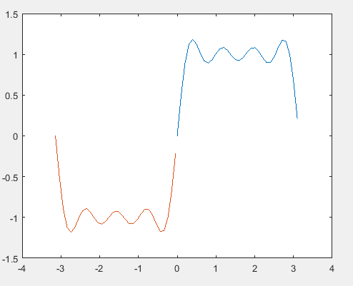

1. Find the results of the following operation by hand and use MATLAB to check your results.

(a) z= 6 >3+ 8 (b) z = 6+3 > 8 (c) z= 4>(2+9) (d) z = (4<7)+3 (e) z = 4<7 +3 (f) z = (4<7)*5 (g) z = 4< (7*5 ) (h) z = 2/5>=5

**Solution:**

>> z=6>3+8

z =

0

>> z=6+3>8

z =

1

>> z=4>(2+9)

z =

0

>> z=(4<7)+3

z =

4

>> z=4<7+3

z =

1

>> z=(4<7)*5

z =

5

>> z=4<(7*5)

z =

1

>> z=2/5>=5

z =

0

1. For the arrays x and y given below, Use MATLAB to find all the elements in x that are greater than the corresponding elements in y.

X = [-3 0 0 2 6 8] y= [-5 -2 0 3 4 10]

**Solution:**

>> x= [-3 0 0 2 6 8];

>> y= [-5 -2 0 3 4 10];

>> for i=1:6 if x(i)>y(i)

disp(x(i)) end

end

**OUTPUT:**

-3

0

6

1. The priceA and priceB given below contains the price in dollars of two stocks over 10 days. Use MATLAB to determine how many days the price of stock A was above the price of stock B.

PriceA = [19, 18, 22, 21, 25, 19, 17, 21, 27, 29]

PriceB = [22, 17, 20, 19, 24, 18, 16, 25, 28, 27]

**Solution:**

>> priceA=[19,18,22,21,25,19,17,21,27,29];

>> priceB=[22,17,20,19,24,18,16,25,28,27];

>> count=0;

>> for i=1:10

if priceA(i)>priceB(i) count=count+1;

end end

**OUTPUT :**

>> count count =

7

1. The arrays priceA, priceB and priceC given below contains the price in dollars of three stockes over 10 days.
2. Use MATLAB to determine how many days the price of stock A was above both the price of stock B and stock C.
3. Use MATLAB to determine how many days the price of stock A was above either the price of stock B or price of stock C.
4. Use MATLAB to determine how many days the price of stock A was above both the price of stock B and stock C but not both.

priceA = [19, 18, 22, 21, 25, 19, 17, 21, 27, 29]

PriceB = [22, 17, 20, 19, 24, 18, 16, 25, 28, 27]

PriceC = [17, 13, 22, 23, 19, 17, 20, 21, 24, 28]

**Solution:**

>> priceA=[19,18,22,21,25,19,17,21,27,29];

>> priceB=[22,17,20,19,24,18,16,25,28,27];

>> priceC=[17,13,22,23,19,17,20,21,24,28];

(1)

>> count=0;

>> for i=1:10

if (priceA(i)>priceB(i)) & (priceA(i)>priceC(i)) count=count+1;

end end

**OUTPUT :**

>> count count =

4

(2)

count=0;

>> for i=1:10

if (priceA(i)>priceB(i)) | (priceA(i)>priceC(i)) count=count+1;

end end

**OUTPUT :**

>> count count =

9

(3)

>> count=0;

>> for i=1:10

if ( ((priceA(i)>priceB(i)) & (priceA(i)<priceC(i))) | ((priceA(i)>priceC(i)) & (priceA(i)<priceB(i)))) count=count+1;

end end

**OUTPUT :**

>> count count =

4

11. Suppose that x = [-3, 0, 0, 2, 5, 8] and y = [-5, -2, 0, 3, 4, 10]. Find the results of the following operations by hand and use MATLAB to check your results.

1. z = y <~ x
2. z = x & y
3. z = x | y
4. z = xor (x ,y)

**Solution:**

>> x=[-3,0,0,2,5,8];

>> y=[-5,-2,0,3,4,10];

>> z=y<~x z =

1 1 1 0 0 0

>> z=x&y z =

1 0 0 1 1 1

>> z=x|y z =

1 1 0 1 1 1

>> z=xor(x,y) z =

0 1 0 0 0 0

1. Write a program that accepts a numerical value x from 0 to 100 as input and computes and displays the corresponding letter grade by the following table.

A x ≥ 90

B 80 ≤ x ≤ 89

C 70 ≤ x ≤ 79

D 60 ≤ x ≤ 69 F x < 60

**Solution:**

x=input('Enter Value :'); if x>=90

disp('A')

elseif x>=80 & x<=89 disp('B')

elseif x>=70 & x<=79 disp('C')

elseif x>=60 & x<=69

disp('D') else

disp('F') end **OUTPUT :**

>> file

Enter Value :78 C

1. Create a vector for x over the range -2π ≤ x ≤ 2π. Use MATLAB to plot both sinh(x) and (e^x-e^-x)/ 2 to show that they are the same function.

**Solution:**

x=-2*pi:0.1:2*pi;

>> val1=sinh(x);

>> val2=(exp(x)-exp(-x))/2;

>> plot(x,val2)

>> hold on

>> plot(x,val1)

**GRAPHS :**

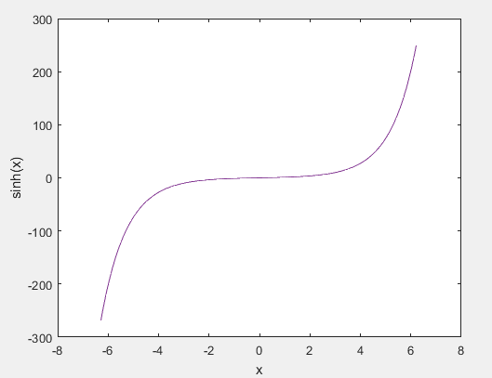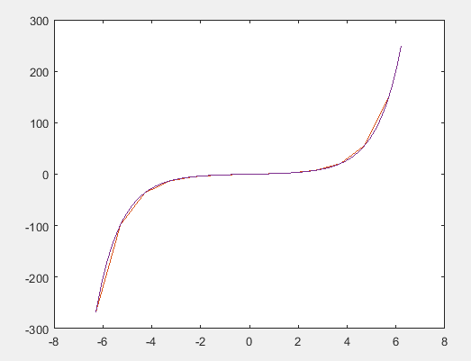

1. Create an anonymous function for 10e^-2x and use it to plot the function over the range 0 ≤ x ≤ 2.

**Solution:**

>> x=0:0.5:2;

>> fun=@(x) 10*exp(-2.*x);

>> fun_many=[fun(0) fun(0.5) fun(1) fun(1.5) fun(2)];

>> plot(x,fun_many)

**GRAPH :**

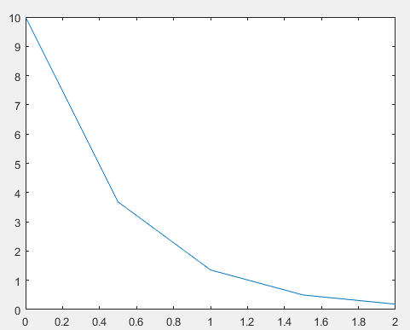

1. a. Create the vector X having 50 logarithmically spaced values starting at 10 and ending at 1000.

b. Create the vector X having 20 logarithmically spaced values starting at 10 and ending at 1000.

|  |  |  |  |  |  |  |  |  |
| --- | --- | --- | --- | --- | --- | --- | --- | --- |
| **Solution:** |  | | | | | | | |
| (A) |
| >> x=10:20:1000; |
| >> y=log(x) |
| y = |
| Columns 1 through 14 |
| 2.3026 3.4012 3.9120 | 4.2485 | 4.4998 | 4.7005 | 4.8675 | 5.0106 | 5.1358 | 5.2470 | 5.3471 |
| 5.4381 5.5215 5.5984 |  |  |  |  |  |  |  |  |
| Columns 15 through 28 |  |  |  |  |  |  |  |  |
| 5.6699 5.7366 5.7991 | 5.8579 | 5.9135 | 5.9661 | 6.0162 | 6.0638 | 6.1092 | 6.1527 | 6.1944 |
| 6.2344 6.2729 6.3099 |  |  |  |  |  |  |  |  |
| Columns 29 through 42 |  |  |  |  |  |  |  |  |
| 6.3456 6.3801 6.4135 | 6.4457 | 6.4770 | 6.5073 | 6.5367 | 6.5653 | 6.5930 | 6.6201 | 6.6464 |
| 6.6720 6.6970 6.7214 |  |  |  |  |  |  |  |  |
| Columns 43 through 50 |  |  |  |  |  |  |  |  |
| 6.7452 6.7685 6.7912 | 6.8134 | 6.8352 | 6.8565 | 6.8773 | 6.8977 |  |  |  |

(B)

>> x=10:50:1000;

>> y=log(x) y =

Columns 1 through 14

2.3026 4.0943 4.7005 5.0752 5.3471 5.5607 5.7366 5.8861 6.0162 6.1312 6.2344

6.3279 6.4135 6.4922

Columns 15 through 20

6.5653 6.6333 6.6970 6.7569 6.8134 6.8669

16). Type this matrix in MATLAB and use MATLAB to carry out the following instructions.

A=[3 7 -4 12; -5 9 10 2 ; 6 13 8 11;15 5 4 1]

1. Create a vector v consisting of the elements in the second column of A.
2. Create a vector w consisting of the elements in the second row of A.

**Solution:**

>> a=[3 7 -4 12;-5 9 10 2;6 13 8 11;15 5 4 1]

a =

|  |  |  |  |
| --- | --- | --- | --- |
| 3 | 7 | -4 | 12 |
| -5 | 9 | 10 | 2 |
| 6 | 13 | 8 | 11 |
| 15 | 5 | 4 | 1 |

(A)

>> v=a(:,2)

v =

7

9

13

5 (B)

>> w=a(2,:)

w =

-5 9 10 2

1. Type this matrix in MATLAB and use MATLAB to carry out the following instructions.

A=[3 7 -4 12; -5 9 10 2 ; 6 13 8 11;15 5 4 1]

1. Sort each column and store the result in an array B.
2. Sort each row and store the result in an array C.
3. Add each column and store the result in an array D.
4. Add each row and store the result in an array E.

**Solution:**

>> a=[3 7 -4 12;-5 9 10 2;6 13 8 11;15 5 4 1]

a =

|  |  |  |  |
| --- | --- | --- | --- |
| 3 | 7 | -4 | 12 |
| -5 | 9 | 10 | 2 |
| 6 | 13 | 8 | 11 |
| 15 | 5 | 4 | 1 |
| (A) |  |  |  |

>> b=sort(a) b =

|  |  |  |  |
| --- | --- | --- | --- |
| -5 | 5 | -4 | 1 |
| 3 | 7 | 4 | 2 |
| 6 | 9 | 8 | 11 |

15 13 10 12 (B)

>> c=sort(a,2) c =

-4 3 7 12

|  |  |  |  |
| --- | --- | --- | --- |
| -5 | 2 | 9 | 10 |
| 6 | 8 | 11 | 13 |
| 1 | 4 | 5 | 15 |
| (C) |  |  |  |

>> d=sum(a) d =

19 34 18 26

(D)

>> e=sum(a,2) e =

18

16

38

25

1. Given the matrices A=[-7 11; 4 9]

B=[4 -5;12 -2]

C=[-3 -9;7 8]

Use MATLAB to

1. Find A + B + C.
2. Find A – B + C.
3. Verify the associative law (A + B) + C = A + (B + C)
4. Verify the commutative law A + B + C = B + C + A = A + C + B

**Solution:**

>> a=[-7 11;4 9];

>> b=[4 -5;12 -2];

>> c=[-3 -9;7 8];

(A)

>> a+b+c ans =

-6 -3

23 15

(B)

>> a-b-c ans =

-8 25

-15 3

(C)

>>E= (a+b)+c E=

-6 -3

23 15

>>F= a+(b+c) F=

-6 -3

23 15

>> isequal(E,F) ans =

1

(D)

>> G=a+b+c G=

-6 -3

23 15

>>H= b+c+a H =

-6 -3

23 15

>>I= a+c+b I =

-6 -3

23 15

>> isequal(G,H,I) ans =

1

19 ) Use MATLAB to plot the polynomials *y*=3*x*4-6*x*3+8*x*2+4*x*+90 and z=3*x*3+5*x*2-8*x*+70 over the interval -3 ≤ *x* ≤ 3. Properly label the plot and each curve. The variables *y* and *z* represent current in milliamperes; the variable *x* represents voltage in volts.

**Solution:**

>> x=-3:0.1:3;

>> y=3*x.^4-6*x.^3+8*x.^2+4.*x+90;

>> z=3*x.^3+5*x.^2-8.*x+70;

>> plot(x,y)

>> hold on

>> plot(x,z)

>> xlabel('Voltage(V)')

>> ylabel('Current(mA)')

**GRAPH :**

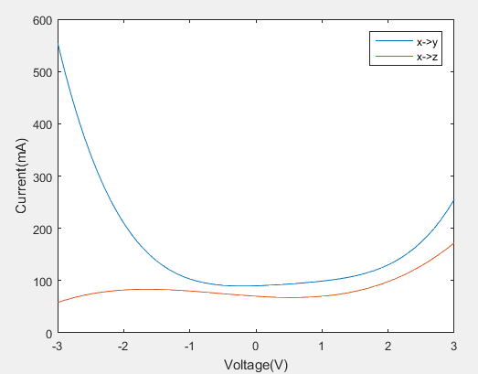

1. Set a matrix A1 as a 3 × 3 matrix that increments from 1 to 9, horizontally and then vertically.

You can type this by hand into the script or use MATLAB functions.

**Solution:**

A0=[1:3;4:6;7:9] A0 =

|  |  |  |
| --- | --- | --- |
| 1 | 2 | 3 |
| 4 | 5 | 6 |
| 7 | 8 | 9 |

>> A1=A0' A1 =

1 4 7

2 5 8

3 6 9

1. Set a matrix A2 as a 3 × 3 matrix with a diagonal of 4 and the rest of the entries as 3. Use MATLAB functions to do this.

**Solution:**

>> A2=eye(3)+3;

A2 =

|  |  |  |
| --- | --- | --- |
| 4 | 3 | 3 |
| 3 | 4 | 3 |
| 3 | 3 | 4 |

1. Set a matrix A3 as a 3 × 3 matrix that is an upper triangular matrix consisting of only ones on and above the diagonal and zero otherwise. Use MATLAB functions to do this.

**Solution:**

>> A3=triu(ones(3)) A3 =

|  |  |  |
| --- | --- | --- |
| 1 | 1 | 1 |
| 0 | 1 | 1 |
| 0 | 0 | 1 |

1. Create a block matrix B using A0, A1, A2, and A3 that has the form A0 A1

A2 A3

**Solution:**

B=[A0 A1;A2 A3];

B =

|  |  |  |  |  |  |
| --- | --- | --- | --- | --- | --- |
| 1 | 2 | 3 | 1 | 4 | 7 |
| 4 | 5 | 6 | 2 | 5 | 8 |
| 7 | 8 | 9 | 3 | 6 | 9 |
| 4 | 3 | 3 | 1 | 1 | 1 |
| 3 | 4 | 3 | 0 | 1 | 1 |
| 3 | 3 | 4 | 0 | 0 | 1 |

1. Create random matrix A4 of 5X5. Extract the third row and second column of the matrix and save it to another variable A5.

**Solution:**

>> A4=rand(5) A4 =

|  |  |  |  |  |
| --- | --- | --- | --- | --- |
| 0.5841 | 0.2607 | 0.1615 | 0.4709 | 0.0688 |
| 0.1078 | 0.5944 | 0.1788 | 0.6959 | 0.3196 |
| 0.9063 | 0.0225 | 0.4229 | 0.6999 | 0.5309 |
| 0.8797 | 0.4253 | 0.0942 | 0.6385 | 0.6544 |
| 0.8178 | 0.3127 | 0.5985 | 0.0336 | 0.4076 |

>> A5_1=A4(3,:);

>> A5_2=A4(:,2);

>> A5_2=A5_2';

>> A5=vertcat(A5_1,A5_2) A5 =

0.9063 0.0225 0.4229 0.6999 0.5309

0.2607 0.5944 0.0225 0.4253 0.3127

1. When a constant voltage was applies to certain motor initially at rest, its rotation speed s versus time was measured. The data appear in the following table.

|  |
| --- |
| Time 1 2 3 4 5 6 7 8 10 |
| Speed 1210 1866 2301 2564 2724 2881 2879 2915 3010. |

Plot the rotational speed versus time using open red circles. Then plot the following function on the same graph.

s(t) =b(1-e^-ct); b = 3010 and c = 0.1: 0.1: 0.6 What values of c provides the best fit to the data? **Solution:**

>> speed=[1210 1866 2301 2564 2724 2881 2879 2915 3010];

>> time=[1 2 3 4 5 6 7 8 10];

>> plot(speed,time,'ro')

>> xlabel('time')

>> ylabel('speed')

**GRAPH :**

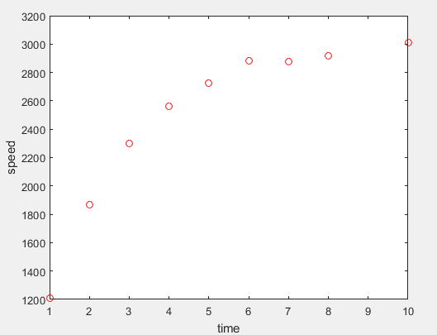

>> t=[1 2 3 4 5 6 7 8 10];

>> s=[1210 1866 2301 2564 2724 2881 2879 2915 3010];

>> b=3010;c=0.1:0.060:0.6;

>> s_t=b*(1-exp(-(c.*t)));

>> plot(t,s,'ro')

>> hold on

>> plot(t,s_t)

>> xlabel('time')

>> ylabel('speed')

**GRAPH :**

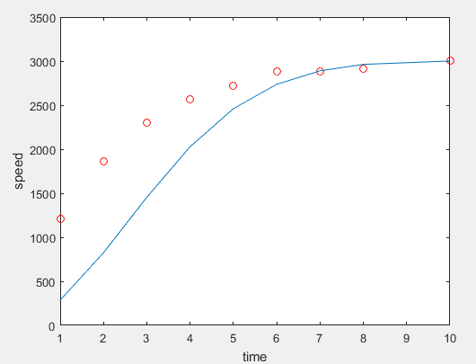

1. An approximation to the function sin(x) is sin x ≈ x- x3/6. Plot the sin x function and 20 evenly spaced error bars representing the error in the approximation.

**Solution :**

>> x=0:0.1:2;

>> apx=x-x.^3/6;

>> error=apx-sin(x);

>> errorbar(x,apx,error)

**GRAPH :**

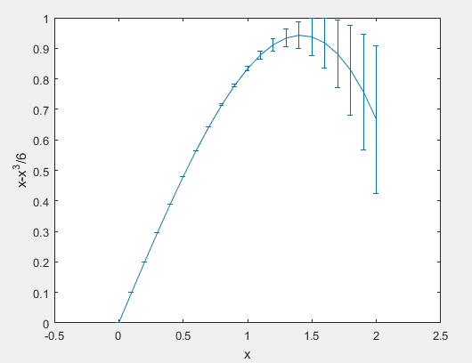

1. The following function describes oscillations in some mechanical structures and electric circuits.

*z*(*t*)*=e t* /Tsin(wt + phi)

In this function *t* is time, and *w* is the oscillation frequency in radians per unit time. The oscillations have a period of *2π/w*, and their amplitudes decay in time at a rate determined by , which is called the time constant. The smaller , which is called the *time constant*. The smaller is, the faster oscillations die out.

Suppose that = 0, *w* = 2, and can have values in the range 0.5 ≤ x≤ 10

sec. Then the preceding equation becomes

*z*(*t*)*=e t* /Tsin(2*t*)

Obtain a surface plot and a contour plot of this function to help

visualize the effect of for 0 ≤ x≤ 15 sec. Let *x* variable be time *t* and the *y*

variable be T .

**Solution:**

>> tau=0:0.1:15;

>> t=pi;

>> z_1=exp(-t./tau)*sin(2*t);

>> tau=0.5:0.063:10;

>> z_2=exp(-t./tau)*sin(2*t);

>> Z=[z1;z2];

>> Z=[z_1;z_2];

>> contour(Z)

>> plot(Z)

>> surface(Z)

**GRAPHS :**

